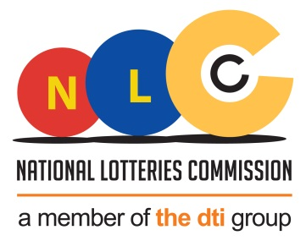
Media Statement
NLC saddened by the passing of Mr Goliath Munro
PRETORIA. 5 January 2016 The National Lotteries Commission (NLC) is saddened by the passing of Mr Goliath Munro, who served on its Sport and Recreation Distributing Agency (SRDA).
On behalf of the Board, Distributing Agencies and Staff at the NLC, Acting Commissioner Mr Phillemon Letwaba has conveyed heartfelt condolences to Munro’s family and the sporting fraternity at large.
Said Letwaba, “His keen interest in cross country as a child planted the seed for his future involvement in athletics administration, his role as President of the Western Cape Provincial Sports Confederation for the last five years, and a member of the NLC’s SRDA since 2013, and just like his name, he was a giant in the industry. A giant we have all been honoured to work with”.
Munro’s illustrious career has left an indelible mark on the landscape of Sport administration, and he will be remembered fondly by those who worked closely with him.
The National Lotteries Commission is honoured to have had an opportunity to benefit from, and learn from his experience.
-Ends-

